# Outlook Graph API with Watson Orchestrate Workshop

## Schedule meeting with Outlook

Login to Orchestrate and select Chat:

Select Skill flows:

Select NTC Book Meeting:

Enter the recipient of the meeting request

**Recipient:** [ncrowther@uk.ibm.com](mailto:ncrowther@uk.ibm.com)

Press Apply.

Another dialog box appears, enter **exactly** the following:

**windowStartDateTime**: 2024-08-16 08:00 GMT+00:00

**windowEndDateTime**: 2024-08-30 08:00 GMT+00:00

**duration**: PT1H

You should see available time slots for the given email address. Select any slot:

Press Apply. The following dialog box appears. The selected slot times are prefilled, but the  **time offset must be set to GMT+01:00**. Use your email address for the recipient and any values for remaining fields.

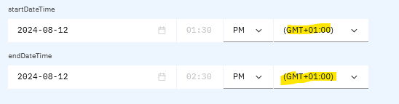

Press Apply. You should see the message “Meeting Booked” and a meeting invite for the selected time slot should arrive in your inbox.

# Appendix A: Setting up Outlook Graph API

Login to Microsoft Graph: <https://developer.microsoft.com/en-us/graph/graph-explorer>

Navigate to the Outlook Calendar calls:

Select *Schedule a meeting*

Select *Modify permissions* tab. Ensure all privileges are set:

If you are using Postman, copy the access token:

Create Meeting request body:

{

    "subject": "Let's go for lunch",

    "body": {

        "contentType": "HTML",

        "content": "Does noon work for you?"

    },

    "start": {

        "dateTime": "2024-08-09T11:00:25.357Z",

        "timeZone": "UTC"

    },

    "end": {

        "dateTime": "2024-08-09T12:00:25.357Z",

        "timeZone": "UTC"

    },

    "location": {

        "displayName": "Harry's Bar"

    },

    "attendees": [

        {

            "emailAddress": {

                "address": "ncrowthe@talk21.com",

                "name": "nigel crowther"

            },

            "type": "required"

        }

    ],

    "allowNewTimeProposals": **true**

}

Hit *Run Query*. Check the Outlook calendar to verify the meeting has been scheduled:

